**DATADOG DOCUMENTATION**

1. Login to datadog web site ( <https://app.datadoghq.com/> )
2. Create API keys and Application keys ( https://app.datadoghq.com/account/settings#api/ ) which we have to use in our local services.

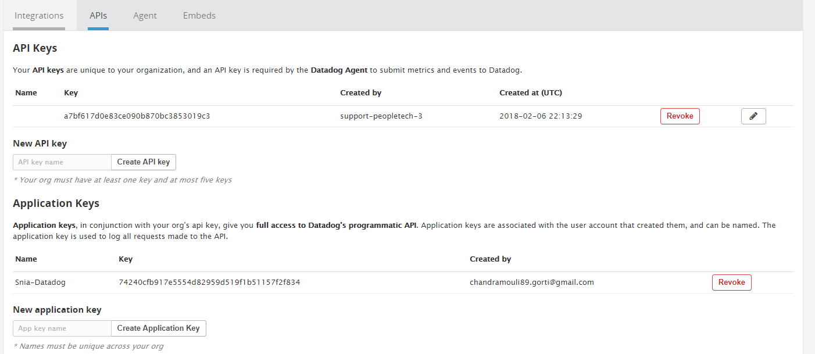

1. Install datadog to our Local machine Ubuntu 16.04
2. Installation Steps:

Run the below commands to install datadog in local machine.

* + sudo apt-get update
  + sudo apt-get install apt-transport-https

Set datadog deb repo on local and import datadog api key.

* + sudo sh -c "echo 'deb https://apt.datadoghq.com/ stable 6' > /etc/apt/sources.list.d/datadog.list"
  + sudo apt-key adv --recv-keys --keyserver hkp://keyserver.ubuntu.com:80 382E94DE

Use local apt repo and install the agent

* + sudo apt-get update
  + sudo apt-get install datadog-agent

Place our API key and copy it to config

* + sudo sh -c "sed 's/api_key:.*/api_key: a7bf617d0e83ce090b870bc3853019c3/' /etc/datadog-agent/datadog.yaml.example > /etc/datadog-agent/datadog.yaml"

Start Agent

* + sudo systemctl restart datadog-agent.service

1. Run Datadog :

Start Agent as a service

* + sudo /etc/init.d/datadog-agent start

Restart agent running as a service

* + sudo /etc/init.d/datadog-agent restart

Status page of running agent

* + sudo /etc/init.d/datadog-agent info

**Dashboard**:

* We can create a new dashboard from right menu of datadog page.
* After creating dashboard, we can select graphs to visualize the data.

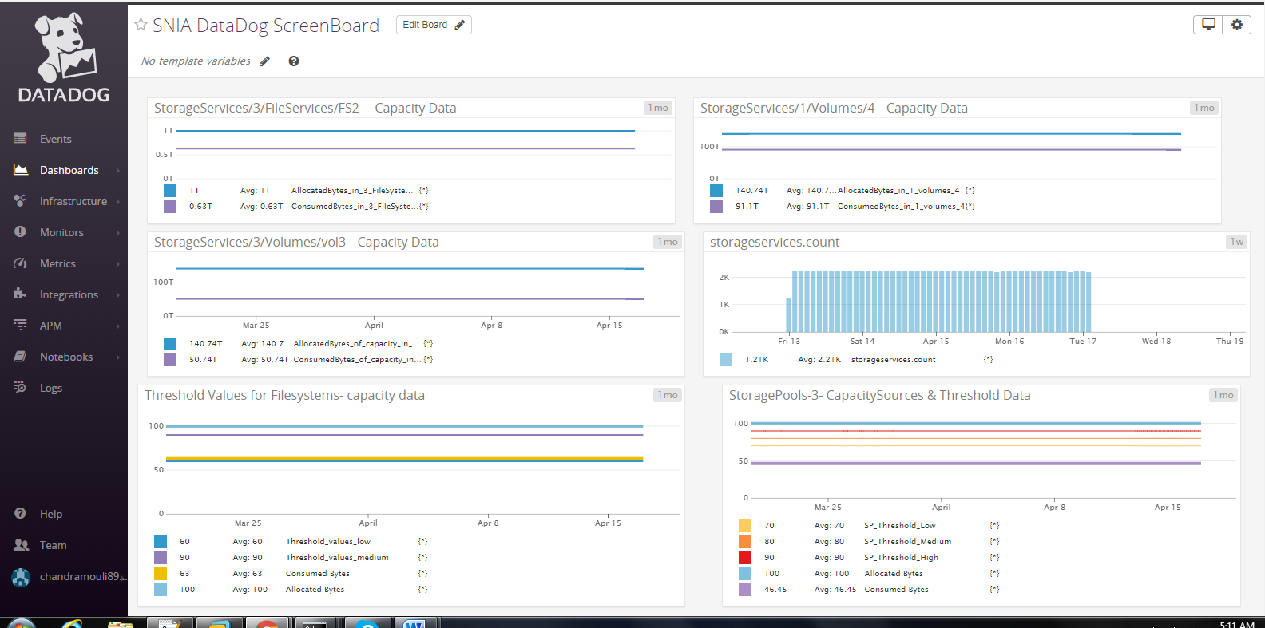

The below is the graph editor window where we can edit the visualization ,choose metrics and events , adds filters and add functionalities if requires.

